## Defining the Module

## 

To create a module, we use the Angular module Method and this method has two overloads, the first parameter is the modules name if it’s the main module set it to the application name. the second parameter is a array of dependency is a reference to any other module. Also known as injectables

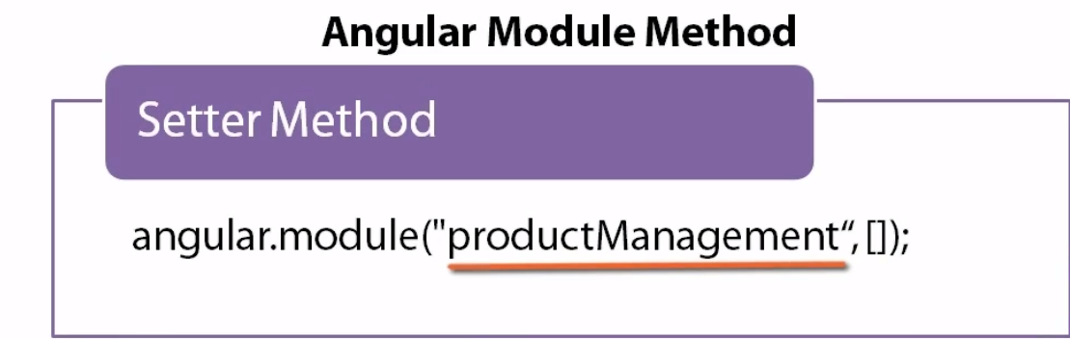

Use the second overload with one parameter to look up and reference an existing module 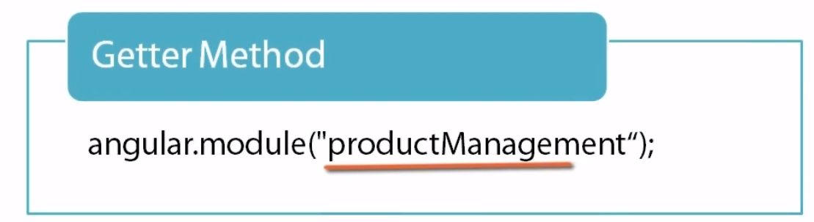

Function declaration requires a name

Function expression is to just wrap it in parentheses, the existence of parentheses implies that the contents must be an expression.

Here the app variable will be used locally instead of being global

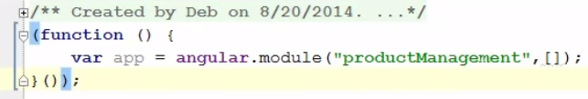

In “use strict” mode JavaScript will catch some common coding mistakes and throw exceptions. For example, using an unassigned variable